CURRICULUM VITAE
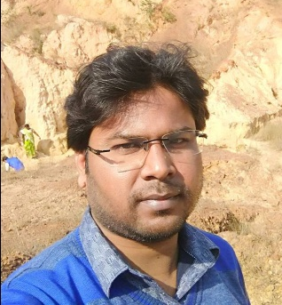

Personal Information
Name : SANJOY DAS

Designation : Assistant Professor of Political Science

Date of Joining : 10th December, 2016

Personal Contact
Permanent : Vill + P.O. – Shyambazar, Dist. – Hooghly,
West Bengal
Present : Department of Political Science,
M.U.C. Women’s College, B.C.Road, Burdwan,
West Bengal, Pin: 713104
Email : das21788@rediffmail.com
Educational Qualifications:
a) Madhyamik: W.B.B.S.E,
Shyambazar G. C. Sen High School, 2004

b) Higher Secondary: W.B.C.H.S.E,
Satberia High School, 2006

c) B.A. (Hons.) in Political Science:
Netaji Mahavidyalaya, Arambagh, Hooghly,
University of Burdwan, 2009

d) M.A. in Political Science: University
Of Burdwan, 2011

e) B.Ed. in Political Science: Pandua College
Of Education, University of Burdwan, 2013

f) M.Phil. In Political Science: University
Of Burdwan, 2017

Other Qualifications : UGC – NET, Dec 2013 & WB – SET, Dec 2013
Specialization : Public Administration and Local Government

Areas of Interest : Public Administration, Political Theory, State Politics in India, Political Thought etc.
.

Employment History
1. Institution : Acharya Sukumar Sen Mahavidyalaya, Gotan, Burdwan, W.B.
Position : Guest Lecturer in Political Science
Tenure : From Nov 2013 to July 2016
2. Institution : Gushkara Mahavidyalaya, Gushkara, Burdwan, W.B.
Position : Guest Lecturer in Political Science
Tenure : From July 2013 to April 2014.

Publications/Paper Presentation:
1. The Changing face of Child labour and Covid-19 in India, Gorteria Journal, Volume 35, Issue 3, March 2022.
2. Assessing the level of education among children, Gorteria Journal, Volume 34, Issue 12, December 2021.
3. Globalization leading to backlash of Religious Exclusion : A study of Rajbanshi Community in northern region of West Bengal at Galsi Mahavidyalaya, Galsi, West Bengal on 14th February, 2019.
4. “Panchayat Byabosthar Madhyame Pichiya pora janojatir Gramonnayone Antarvukti : Mirdde o Pan Sampodayer Ekti Rajnaitik, Orthonaitik O Samajik Obastar Samikhsha”, at ANTARMUKH, MUC Women’s College, Burdwan,West Bengal on 17th February, 2019.

5. “Panchayat Byabosthar Madhyame Gramonnayone Netritter Bhumika: Samprotikkaler Ekti Samikhsha”, at Centre for Studies in Decentralization and Rural Reconstruction (CSDRR), Rabindra Bharati University, Kolkata, West Bengal on 7Th February, 2018.

